Inside of House #3 where a complete clean-out has begun
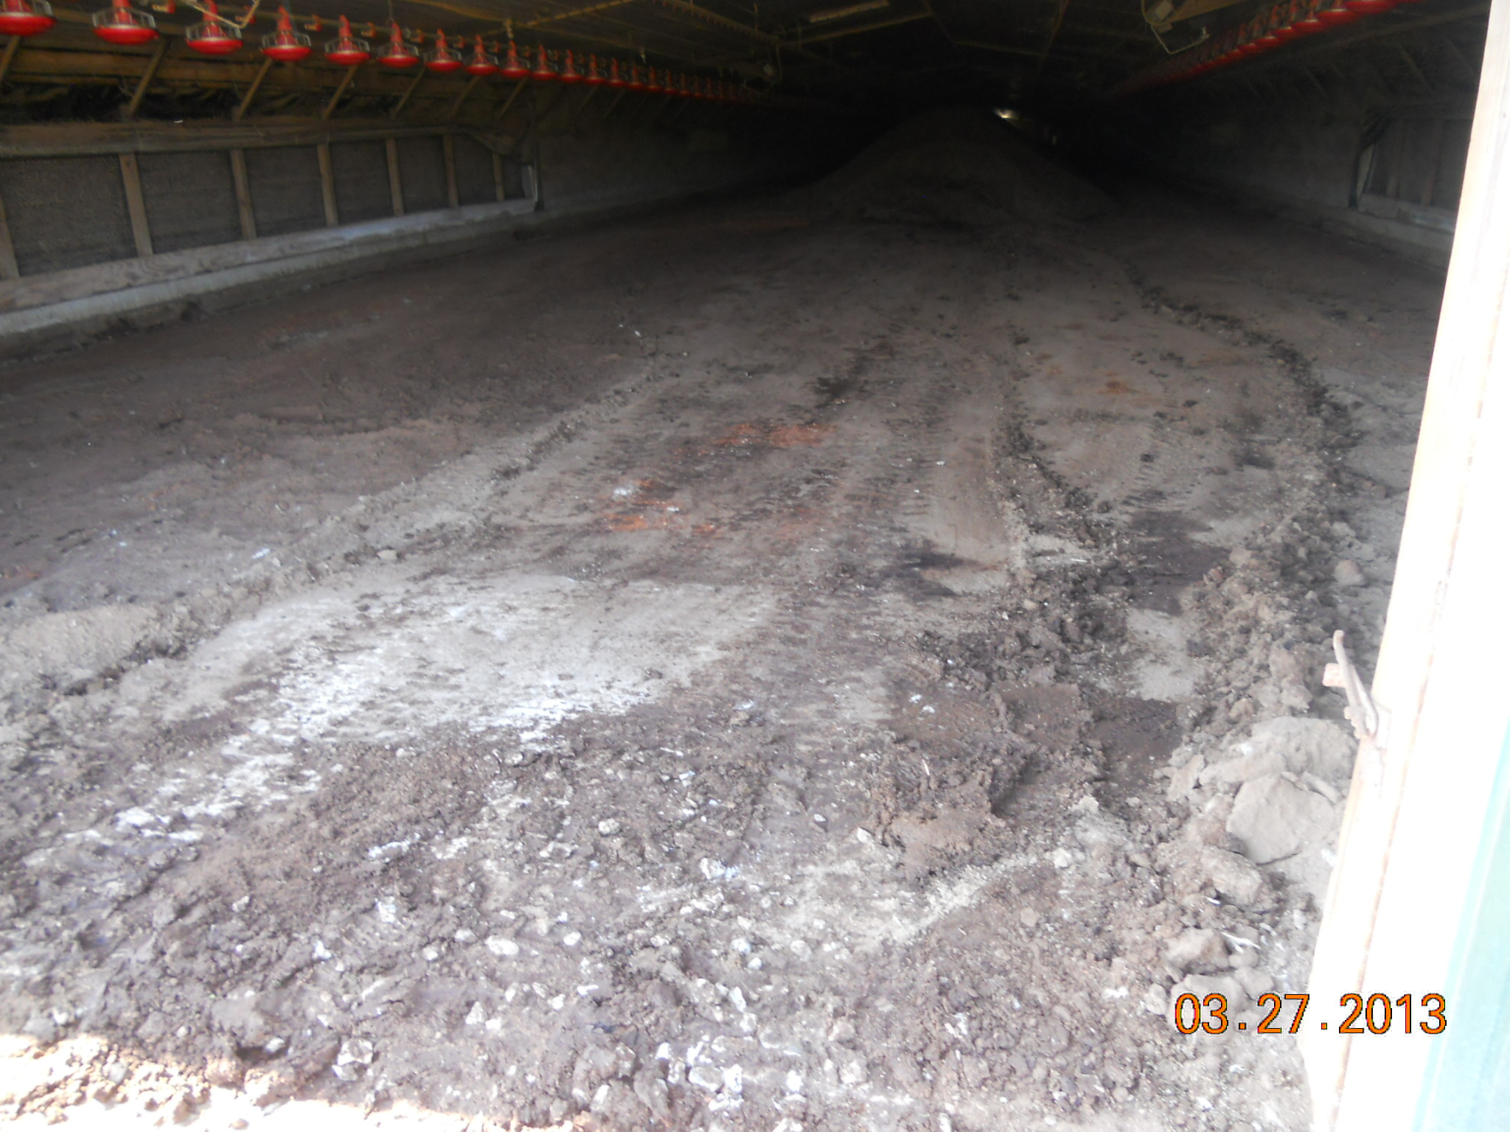
Remaining pile of litter to be removed.
Original clay floor
Litter shed approximately 75% full
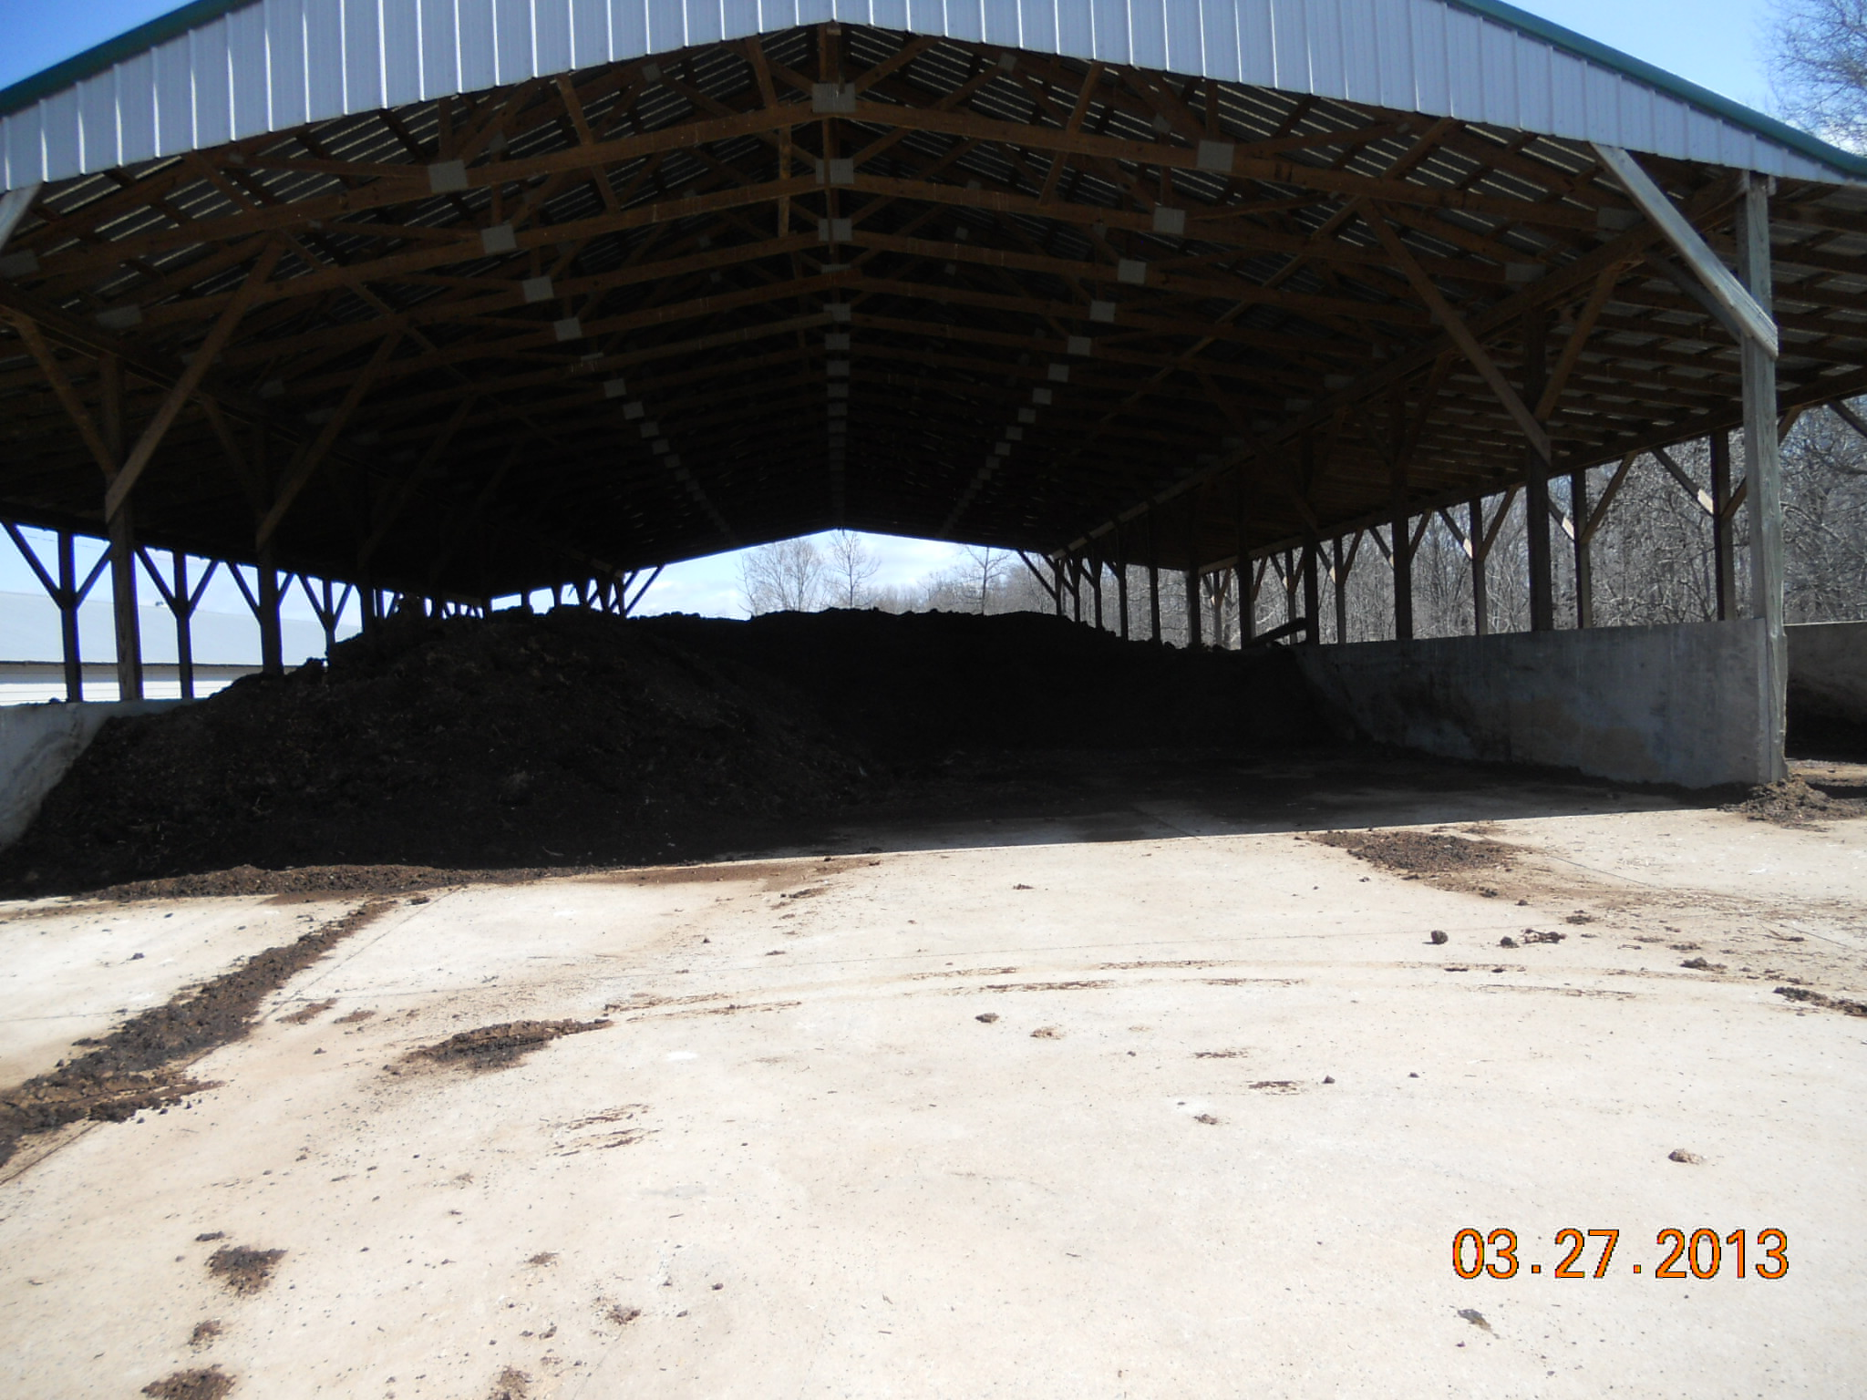
Litter spillage on apron that is to be scraped back under roof

Front of houses #1, #2 and #3
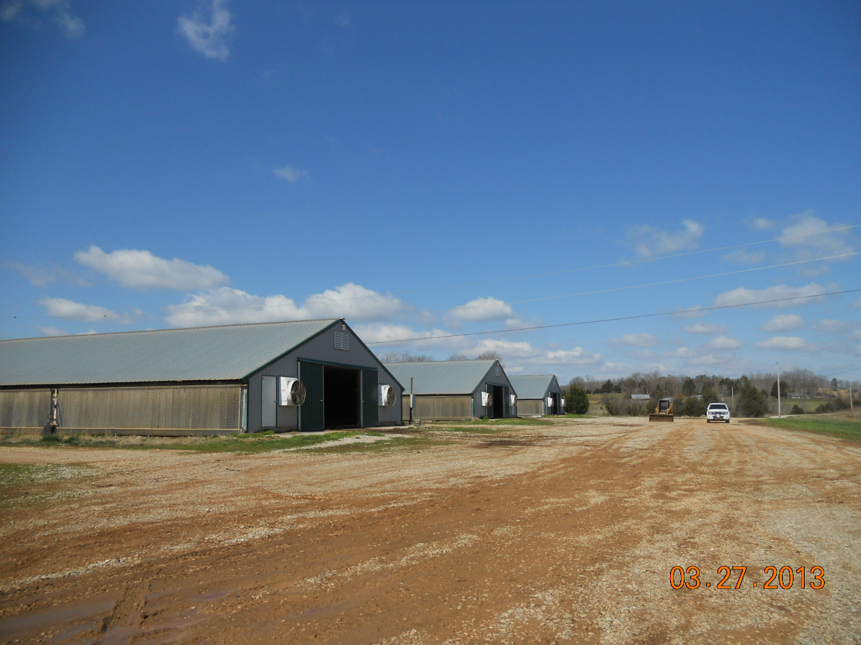
Spillage from the conveyor load out into trucks, to be scooped back under roof

