City of Waynesboro Sewage Treatment Plant
January 27, 2009 site visit
Ryan Owens, TDEC Water Pollution Control
While investigating a complaint of gravel dredging on the Green River near the Waynesboro STP, I noted raw sewage leading from a “bypass” point entering a ditch leading to the Green River. In addition, raw sewage was noted around the outfall point of the Waynesboro STP entering the Green River. I interviewed Mr. Dewayne Staggs, the STP operator. I asked Mr. Staggs if the permit required him to clean up the raw sewage after a bypass. He said “no”. I asked Mr. Staggs where the ditch containing the sewage drained. He said “the Green River”.
An inspection will be planned immediately to thoroughly go over relevant documentation with the operation of the Waynesboro STP.

Attached are photos of the January 27, 2009 site visit.
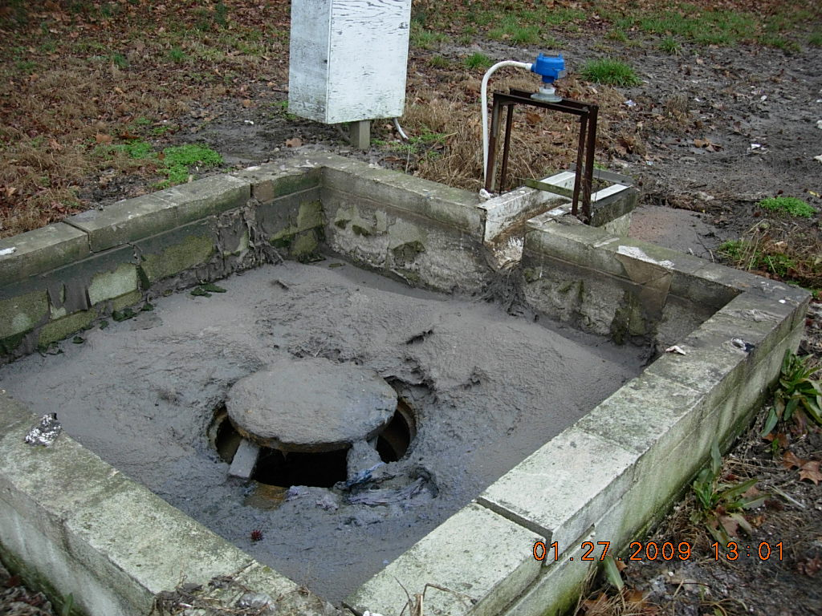
Figure 1: Bypass point for the Waynesboro Sewage Treatment Plant. Gray material is sewage.
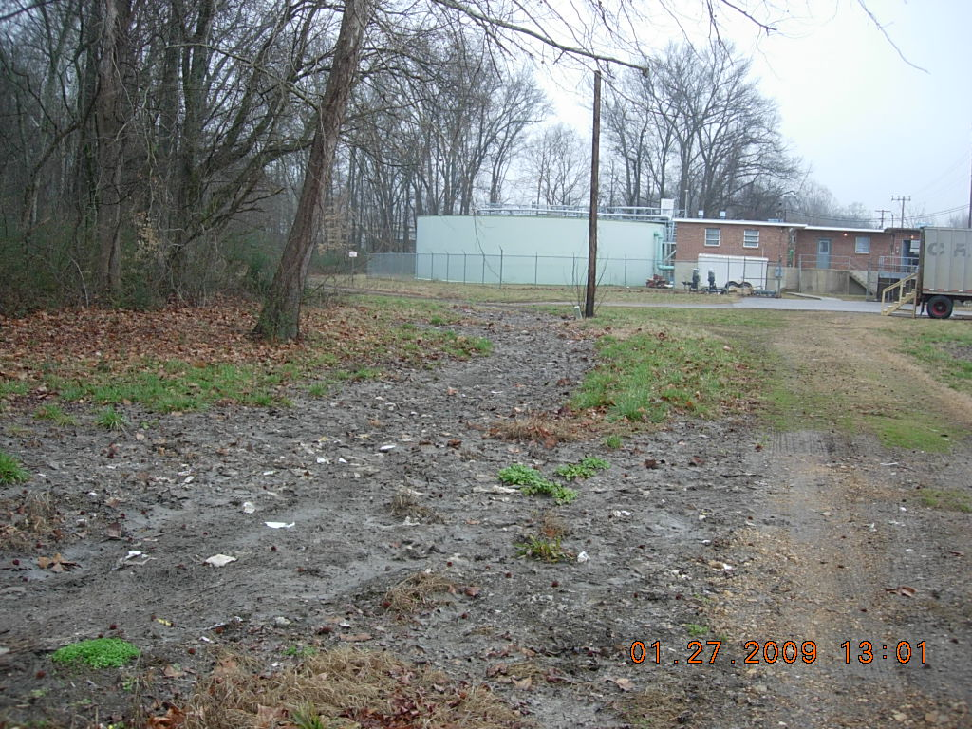
Figure 2: Ditch leading to Green River from Waynesboro STP bypass point. Gray color outlining ditch is sewage.
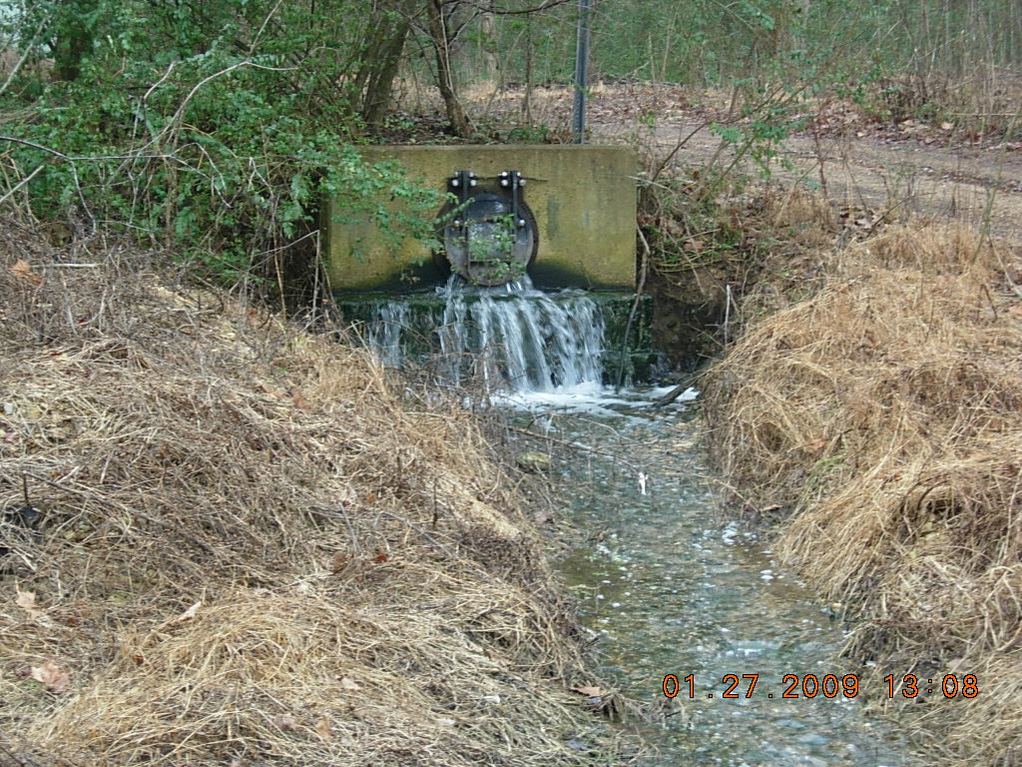
Figure 3: Waynesboro STP outfall point leading to Green River.
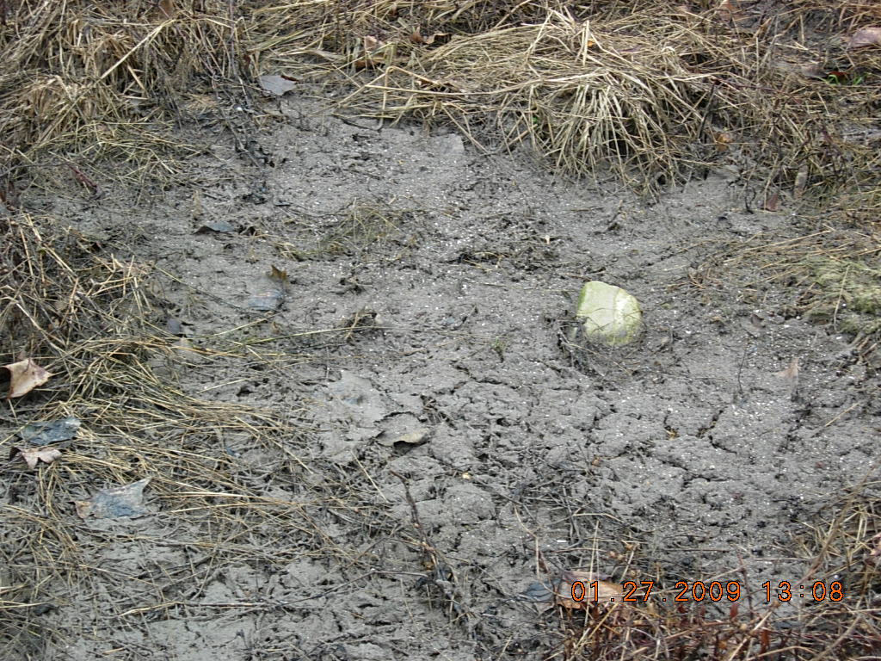
Figure 4: View of sewage deposits adjacent to the outfall of the Waynesboro STP entering the Green River.

